CryptoSim Pro
Web-Based Cryptocurrency Trading Platform

Group n° – METTRE NUMERO GRP
Lilou CONSTANTIN – Dev Data Base / Front End
Lucas NGYEN – Dev Back End
Roméo PIVAT– Dev Front End
Hugo DE SOUSA DIAS – Dev Back End




SUMMARY - CryptoSim Pro

1. Introduction 3
1.1. Project Context and Objectives 3
1.2. Core Features Overview 3
2. System Architecture 4
2.1. Technology Stack Selection 4
2.2. N-Tier Backend Architecture & Data Flow 5
6
2.3. Real-Time Event Engine 6
3. Database Design 8
3.1. Relational Schema & Structural Mapping 8
3.2. Data Persistence Strategy 9
4. Testing Strategy 10
4.1. REST API and WebSocket Validation 10
4.2. Scenario-Based Testing with Bruno 11
7. Screenshots 11
7.1. Front-end Interface and User Views 11
7.2. Backend Execution Logs and HTTP Responses 14
8. Challenges Encountered 14
8.1. Service Lifecycle Conflicts (Resolving the Singleton vs. Scoped dependency issue in the Worker) 14
8.2. High-Frequency Filtering and Performance Optimization 15
8.3. WebSocket Network Security 15
9. Conclusion 15
9.1. Project Summary and Key Achievements 15
9.2. Technical Scalability and Future Enhancements 16

Introduction

Project Context and Objectives

In the rapidly evolving landscape of financial technology, cryptocurrency trading has emerged as a major interest in retail investors. However, high market volatility presents a steep learning curve for newcomers. To address this challenge, this project presents CryptoSim Pro, a web-based cryptocurrency trading simulation platform commissioned as a functional prototype by a fintech startup. The primary business objective is to provide a risk-free environment where new investors can engage with live market dynamics, and trade using virtual currency while monitoring their previous performance and the one of the other users
From an engineering perspective, the project serves as a comprehensive synthesis of modern software development practices. The academic and technical objectives achieved over this 4-week development cycle include:
- Designing and implementing a secure, scalable relational database schema.
- Integrating external high-frequency REST APIs to capture real-time market data.
- Architecting an asynchronous, event-driven backend capable of low-latency data broadcasting.
- Building a responsive, intuitive, and professional user interface featuring advanced data visualization.
- Enforcing industry-standard authentication and authorization mechanisms to safeguard user resources.

Core Features Overview
To deliver a high-fidelity simulation experience, the platform is structured around nine Mandatory Functional Requirements (FR1 to FR9). These requirements translate into a fully unified workflow, mapped across ten dedicated application pages—including a Landing Page, Dashboard, Market View, and Leaderboard—all sharing a cohesive, responsive layout.
The core functional capabilities of the system are categorized as follows:
- Identity & Access Management (FR1): Secure user registration, credential hashing, and stateful session management utilizing JSON Web Tokens (JWT) for subsequent authenticated API interactions.
- Live Market Data Integration (FR3): Dynamic ingestion of cryptocurrency metrics (covering at least 10 major assets) powered by the CoinGecko REST API API, capturing live prices, market capitalizations, and 24-hour variations.
- Virtual Trading Engine (FR4 & FR6): A robust transaction execution layer supporting simulated BUY and SELL orders. The engine natively validates available cash balances and owned asset quantities while automatically enforcing a realistic 0.5% transaction fee, permanently archiving records for historical audits.
- Portfolio Diagnostics & Analytics (FR2 & FR5): A comprehensive dashboard computing consolidated financial indicators, including Net Liquidation Value (NLV), available cash, aggregate asset allocation, and real-time unrealized profit/loss (P&L) margins.
- Social & Engagement Metrics (FR7): A competitive, real-time leaderboard ranking the Top 10 users globally based on their overall investment returns.
- Advanced Tracking Features (FR8 & FR9): A personalized Watchlist allowing users to follow specific assets via clean RESTful routes (/api/WatchList/add/{cryptoId}), coupled with a cutting-edge Price Alert Engine. The alert engine allows users to establish custom price thresholds (ABOVE or BELOW) and leverages WebSockets to push instant notifications the moment a target threshold is breached by the market.

System Architecture

Technology Stack Selection
We decided to build the project based on our previous experience and affinity with technology. As a consequence, the back end is an ASP.NET Core Web API written in C#, due to his static typing, first-class dependency-injection container, and the maturity of its data and security ecosystem which his properties that matter when the system manipulates money-like quantities and manages authentication. Persistence relies on PostgreSQL accessed through Entity Framework Core via the Npgsql provider. The front end is a single-page application built with React and Vite, using React Router for client-side navigation and Recharts for portfolio visualization. Market data is sourced from the CoinGecko public REST API.
Layer | Technology | Role & justification
Back end | ASP.NET Core Web API (C#) | Strongly-typed, high-performance API host with built-in DI and middleware pipeline.
ORM | Entity Framework Core + Npgsql | Code-first mapping between C# entities and PostgreSQL; migrations manage schema evolution.
Database | PostgreSQL | Robust relational engine; decimal(18,8) columns guarantee exact financial precision.
Security | ASP.NET Identity + JWT Bearer | Battle-tested user store with password hashing; stateless JWT auth for the SPA.
Front end | React + Vite + React Router | Component-based SPA with fast tooling and protected client-side routes.
Charts | Recharts | Declarative charts for allocation, P&L and session sparklines.
Market data | CoinGecko REST API | Free source of live prices, market cap, volume and 24h change for major assets.
API testing | Bruno | Version-controllable, scenario-based collection for the REST endpoints.

On the client side, the React application is organized for clarity and reuse. Global state is provided through three React Contexts — an AuthContext (session and JWT), a MarketDataContext (the cached price feed) and a PortfolioContext (positions and derived metrics). While a ProtectedRoute component guards authenticated pages and redirects unauthenticated visitors to the login screen. All network access flows through a single apiClient module that attaches the Bearer token to every request and normalizes the several error shapes returned by the back end (plain string arrays from Identity, { message } objects, { success, message} envelopes) into one readable error, so the UI can present failures consistently.

N-Tier Backend Architecture & Data Flow

The back end follows a strict N-tier layered architecture (or onion architecture) in which each responsibility lives in its own folder and communicates with adjacent layers through interfaces rather than concrete types. This separation keeps the codebase testable and lets any single layer evolve independently, which in our case was pretty useful during the development, allowing us to split tasks and step between developers and test them separately:
- APP — the presentation layer: API controllers (AuthController, MarketController, TradingController…) and the data-transfer objects (DTOs) that shape requests and responses ensuring the security of our backend.
- LOGIC — the business layer: (Ex: AuthService, CryptoPriceService, MiddleOffice BackOffice …), each hidden behind an interface.
- PERSIST — the persistence layer: the AppDb Entity Framework context, the single gateway between C# objects and PostGreSQL.
- MODEL — the domain entities (AppUser, Portfolio, Transaction, Watchlist, PriceAlert).
- COMMON — cross-cutting concerns: the TradingRulesSettings options object, the ServiceException type and the ErrorCode enumeration.

All services are registered with a scoped lifetime in Program.cs, and trading parameters are injected through the strongly-typed IOptions<TradingRulesSettings> pattern so that configuration is read once and shared safely.
The corresponding wiring in Program.cs is deliberately concise — each interface is bound to its implementation with a scoped lifetime, and the trading rules are bound from configuration:
// Program.cs — dependency-injection container
builder.Services.AddDbContext<AppDb>(o =>
o.UseNpgsql(builder.Configuration.GetConnectionString("DefaultConnection")));

builder.Services.AddIdentity<AppUser, IdentityRole>()
.AddEntityFrameworkStores<AppDb>()
.AddDefaultTokenProviders();

builder.Services.Configure<TradingRulesSettings>(
builder.Configuration.GetSection("TradingRules"));

builder.Services.AddScoped<IMiddleOffice, MiddleOffice>();
builder.Services.AddScoped<IBackOffice, BackOffice>();
builder.Services.AddScoped<IAuthService, AuthService>();

builder.Services.AddScoped<IAuthService, AuthService>();

Exemple of the dataflow of a transaction:

- The React client sends a POST to /api/Trading/execute with a TradeRequestDto (CryptoId, Type, Quantity) and a Bearer JWT in the Authorization header.
- TradingController extracts the user identity from the token's NameIdentifier claim and loads the user together with their portfolio positions.
- CryptoPriceService returns the current market snapshot, served either from a 30-second in-memory cache or, on a cache miss, from CoinGecko.
- MiddleOffice.ValidateTrade runs the pre-trade checks: sufficient cash for a BUY (fees included), the global exposure limit, and — for a SELL — position existence and a sufficient owned quantity, which blocks short-selling.
- On approval, the execution price is frozen and BackOffice.ExecuteTradeAsync settles the order: it debits or credits cash, recalculates the weighted-average buy price, updates or removes the portfolio line, and appends an immutable Transaction record.
- Every database mutation is committed atomically through a single SaveChangesAsync call, and a structured { Success, Message } result is returned to the client.

Authentication is stateless: on login the AuthService verifies the credentials through ASP.NET Identity and issues a signed JWT carrying the user's identity claims. The token is signed with HMAC-SHA256 and expires after two hours; the client stores it and replays it on every subsequent request, where the [Authorize] pipeline validates the signature before the controller runs.
// AuthService.LoginUser — JWT issuance
var claims = new[] {
new Claim(JwtRegisteredClaimNames.Sub, user.Id),
new Claim(JwtRegisteredClaimNames.Email, user.Email!),
new Claim(JwtRegisteredClaimNames.Jti, Guid.NewGuid().ToString())
};
var key = new SymmetricSecurityKey(Encoding.UTF8.GetBytes(secret));
var descriptor = new SecurityTokenDescriptor {
Subject = new ClaimsIdentity(claims),
Expires = DateTime.UtcNow.AddHours(2),
SigningCredentials = new SigningCredentials(
key, SecurityAlgorithms.HmacSha256Signature)
};

Real-Time Event Engine
Real-time behaviour rests on two mechanisms.
First, market data is pulled from CoinGecko and cached in a shared IMemoryCache entry with a 30-second time-to-live. Because the cache is shared across all users rather than per-request, dozens of concurrent reads collapse into at most one external call per interval, which allow us to bypass the critical problem of the fact that we are limited to a certain amount of request per minute (and also month on the app). We have decided to track ten major assets: Bitcoin, Ethereum, Solana, Ripple, Cardano, Dogecoin, Polkadot, Litecoin, Chainlink and Stellar.
*
// CryptoPriceService — the cache short-circuits the network
if (_cache.TryGetValue(MarketPricesCacheKey,
out IEnumerable<CryptoPriceDto> cached))
return cached; // instant, no HTTP call

var response = await _httpClient.GetAsync(baseUrl);
response.EnsureSuccessStatusCode();
var data = await response.Content
.ReadFromJsonAsync<Dictionary<string, CoinGeckoSimplePriceData>>();
// ... project each entry into a CryptoPriceDto ...
_cache.Set(MarketPricesCacheKey, result, TimeSpan.FromSeconds(30));

Second, a background worker (implemented as a hosted BackgroundService) periodically compares live prices against every user's active PriceAlert thresholds. When a threshold is breached in the configured direction (ABOVE or BELOW), the alert is marked inactive and a notification is delivered to the owning client. The delivery transport is designed around WebSockets so that the browser receives events without polling thanks to SignalR.

Database Design

Relational Schema & Structural Mapping

The schema builds on the tables provided by ASP.NET Identity (the AspNetUsers / AspNetRoles family). The application user, AppUser, extends IdentityUser with a first name, surname, an initial virtual CashBalance of 100,000 units, and a creation timestamp. Four domain tables hang off the user through a one-to-many relationship, each linked by a UserId foreign key:

Entity | Key fields | Purpose
AppUser | Id, Name, Surname, CashBalance, CreatedAt | Extended Identity user holding the virtual cash balance.
Portfolio | Id, UserId, CryptoId, Quantity, AvgBuyPrice | Open positions with weighted-average cost basis (PRU).
Transaction | Id, UserId, CryptoId, Type, Quantity, Price, Fee, CreatedAt | Immutable, append-only ledger of every executed order.
Watchlist | Id, UserId, CryptoId | Assets a user has chosen to follow.
PriceAlert | Id, UserId, CryptoId, TargetPrice, Direction, IsActive | User-defined price thresholds evaluated by the worker.
Concretely, the extended user and a single portfolio line are declared as plain C# classes; Entity Framework turns them into tables:
Exemple for the AppUser class/table:
public class AppUser : IdentityUser
{
public string Name { get; set; } = "";
public string Surname { get; set; } = "";
public decimal CashBalance { get; set; } = 100000m;
public DateTime CreatedAt { get; set; } = DateTime.UtcNow;
public ICollection<Portfolio>? Portfolios { get; set; }
public ICollection<Transaction>? Transactions { get; set; }
}

public class Portfolio
{
[Key] public int Id { get; set; }
public required string UserId { get; set; }
public required string CryptoId { get; set; }
public decimal Quantity { get; set; }
public decimal AvgBuyPrice { get; set; } // weighted-average cost (PRU)
}

All monetary and quantity columns are mapped to `decimal(18,8)` at the model-builder level. Eight fractional digits are necessary both to represent fractional crypto quantities faithfully and to avoid the rounding drift inherent to floating-point types — a non-negotiable requirement for any system that behaves like a ledger.

protected override void OnModelCreating(ModelBuilder b)
{
base.OnModelCreating(b);
b.Entity<AppUser>() .Property(u => u.CashBalance).HasColumnType("decimal(18,8)");
b.Entity<Portfolio>() .Property(p => p.Quantity) .HasColumnType("decimal(18,8)");
b.Entity<Portfolio>() .Property(p => p.AvgBuyPrice).HasColumnType("decimal(18,8)");
b.Entity<Transaction>().Property(t => t.Price) .HasColumnType("decimal(18,8)");
b.Entity<Transaction>().Property(t => t.Fee) .HasColumnType("decimal(18,8)");
}

Data Persistence Strategy
Persistence follows the Code-First philosophy:
- the C# model is the single source of truth, and the database schema evolves through Entity Framework migrations (InitialIdentitySetup → AddTradingModels → …). The AppDb context also acts as the application's unit of work: changes tracked in memory are only written when a single SaveChangesAsync succeeds, giving all-or-nothing settlement — if any part of an order fails, no partial state reaches the database.
Two further guarantees are worth highlighting. The Transaction table is strictly append-only, forming an auditable history that is never mutated after the fact. And on every additional BUY, AvgBuyPrice is recomputed as a cost-basis weighted average of the existing and incoming lots, so realized and unrealized P&L remain accurate as a position is built up over time. To protect balances and positions from race conditions when two orders for the same user arrive nearly simultaneously, an optimistic-concurrency strategy was introduced so that conflicting writes are detected and rejected rather than silently overwriting one another.
The cost-basis recalculation and the atomic settlement it belongs to are captured in a few lines of the Back Office:
// BackOffice — settling an additional BUY into an existing line
decimal totalQuantity = existing.Quantity + request.Quantity;
decimal totalCostBasis = existing.Quantity * existing.AvgBuyPrice
+ request.Quantity * executionPrice;

existing.AvgBuyPrice = totalCostBasis / totalQuantity; // new weighted PRU
existing.Quantity = totalQuantity;

_context.Transactions.Add(new Transaction { /* immutable ledger entry */ });
await _context.SaveChangesAsync(); // atomic settlement

Testing Strategy

REST API and WebSocket Validation

Validation is enforced in two complementary layers.
- The first is transport / DTO validation driven by on TradeRequestDto: the crypto identifier and order type are required, the type must match the regular expression (BUY|SELL), and the quantity must be strictly positive. Violations are rejected automatically with an HTTP 400 before any business logic runs.
- The second is domain validation inside the MiddleOffice, which owns the financial rules (cash sufficiency, exposure limits and the short-selling ban). Every trading endpoint is protected with the [Authorize] attribute, so requests without a valid JWT are refused with a 401.
The DTO contract makes the first layer declarative: the framework rejects a malformed order before it ever reaches a service:
public class TradeRequestDto
{
[Required] public string CryptoId { get; set; } = "";

[Required]
[RegularExpression("(BUY|SELL)")]
public string Type { get; set; } = "";

[Required]
[Range(0.00000001, double.MaxValue)]
public decimal Quantity { get; set; }
}

The second layer, in the Middle Office, is where the financial guardrails live: cash sufficiency, the global exposure limit, and the short-selling ban:
public class TradeRequestDto
{
[Required] public string CryptoId { get; set; } = "";

[Required]
[RegularExpression("^(BUY|SELL)$")]
public string Type { get; set; } = "";

[Required]
[Range(0.00000001, double.MaxValue)]
public decimal Quantity { get; set; }
}

Scenario-Based Testing with Bruno
- The Bruno collection is organized into authentication, market-data and trade-execution folders. Crucially, it exercises not only the happy paths but also each guardrail, confirming that invalid orders are rejected with a clear message. The main scenarios are summarized below.
Scenario | Request | Expected result
Register / Login | POST /api/Auth/register, /login | 201/200 and a signed JWT returned.
Market snapshot | GET /api/Market/marketprices | 200 with the ten tracked assets.
Valid buy | BUY 0.5 bitcoin | 200 — order settled, cash debited, position opened.
Valid sell | SELL an owned quantity | 200 — order settled, cash credited net of fee.
Insufficient funds | BUY 50 bitcoin | 400 — cash-available check fails.
Short-selling blocked | SELL 10 ethereum (not owned) | 400 — position does not exist.
DTO validation | malformed / negative-quantity body | 400 — DataAnnotations reject the payload.
Transaction history | GET /api/Trading/history | 200 — ledger ordered most-recent-first.

Screenshots

Front-end Interface and User Views
The following figures illustrate the ten application pages and the cohesive, responsive layout shared across the SPA. Final captures will be inserted in place of the placeholders below.

Landing page — product value proposition and call-to-action.
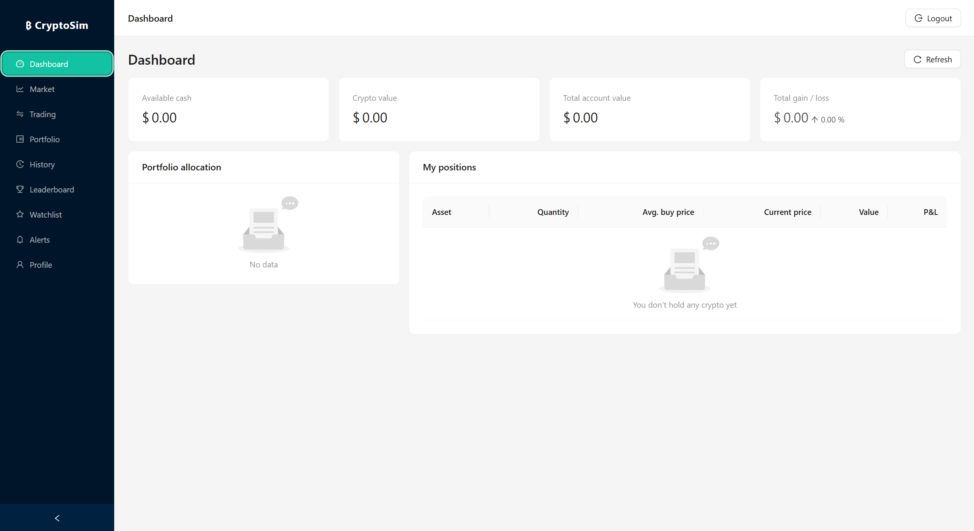

Dashboard — Net Liquidation Value, available cash, allocation donut and unrealized P&L.
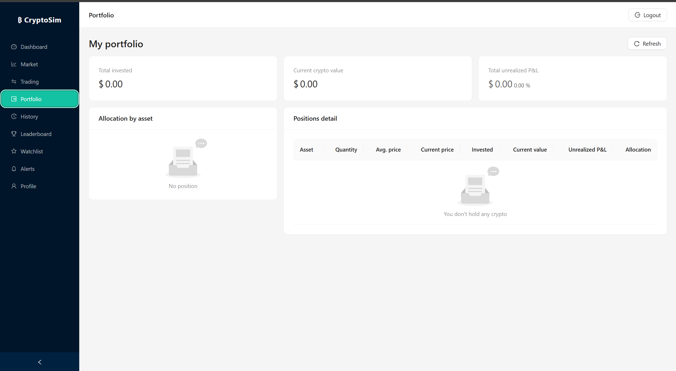

Market view — live prices, market cap, 24h volume and change for the ten tracked assets.
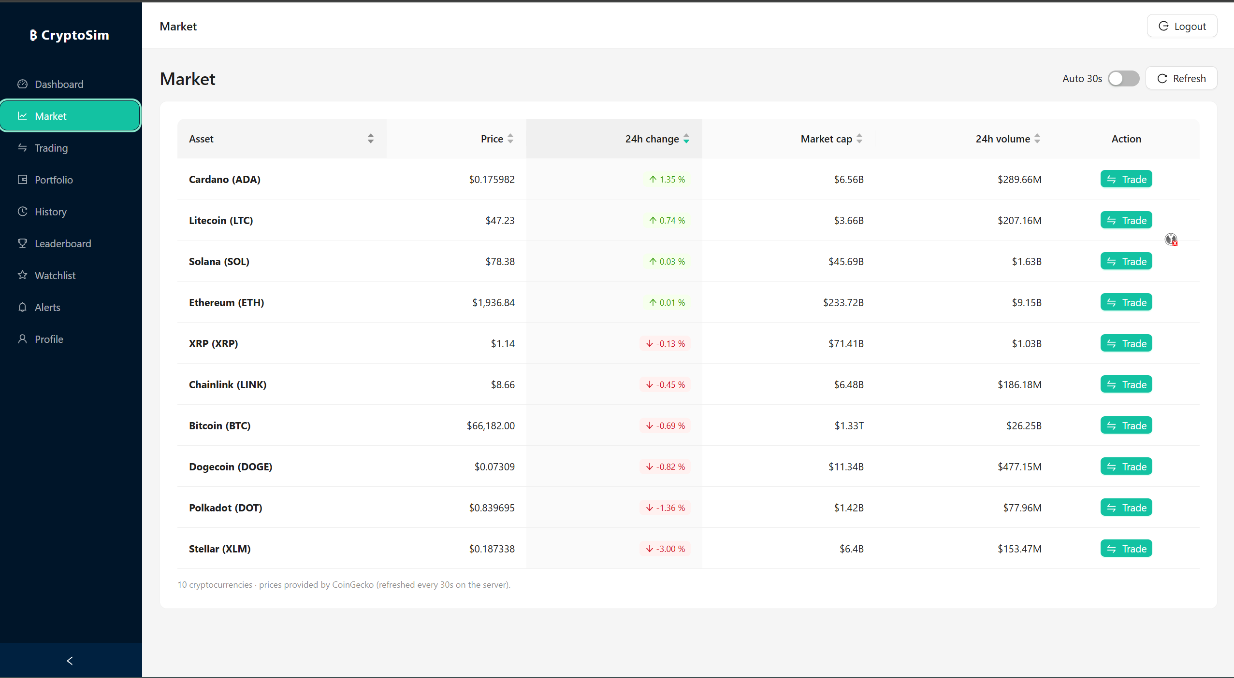
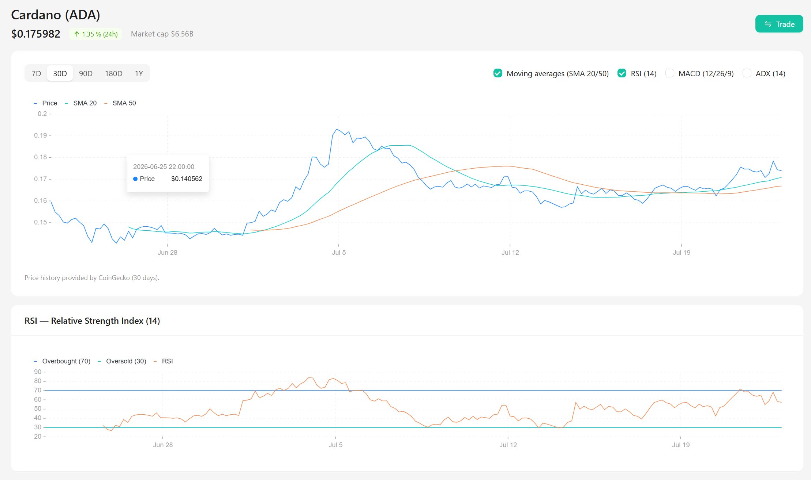

Trading view — order ticket (BUY / SELL, quantity) with real-time price and fee preview.
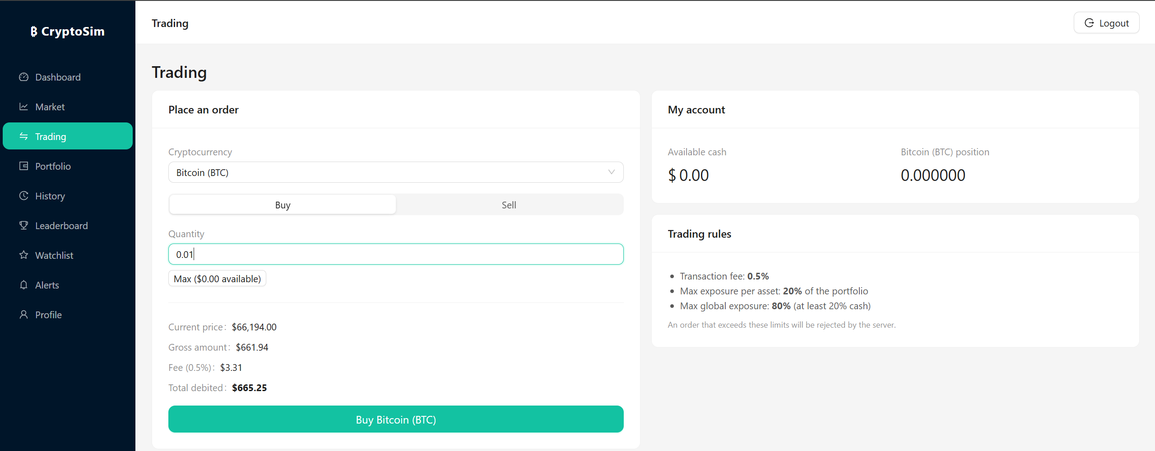

Portfolio page — per-asset positions, average buy price, current value and unrealized P&L.

Leaderboard — global ranking of the top users by overall return.forms with client-side validation.

Authentication — registration and login forms with client-side validation.

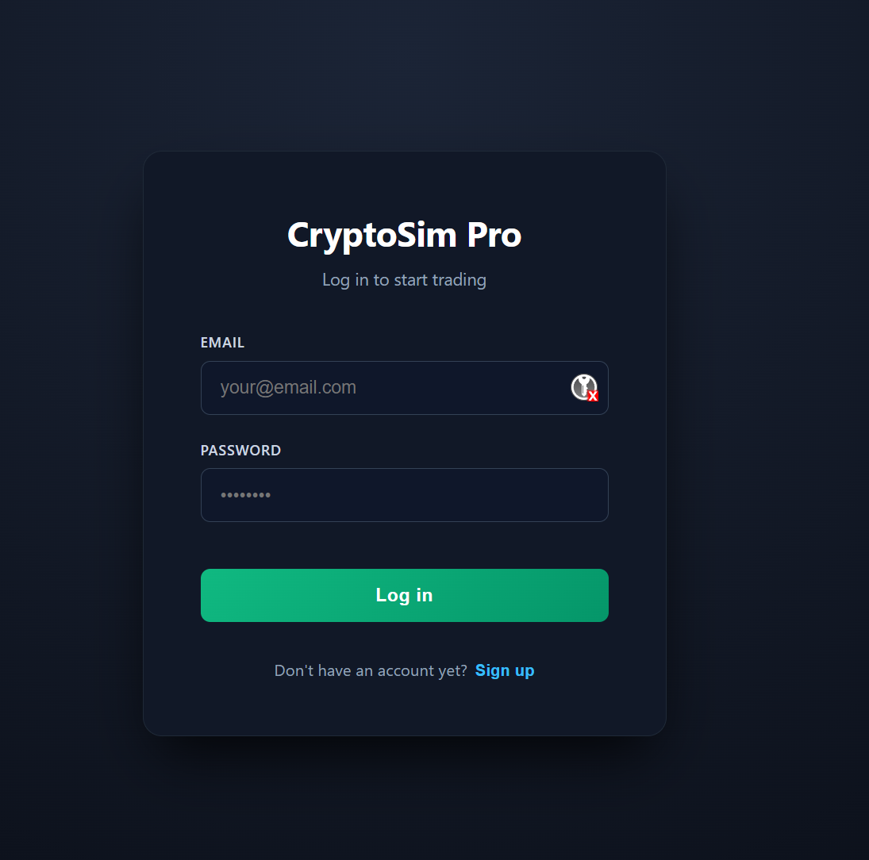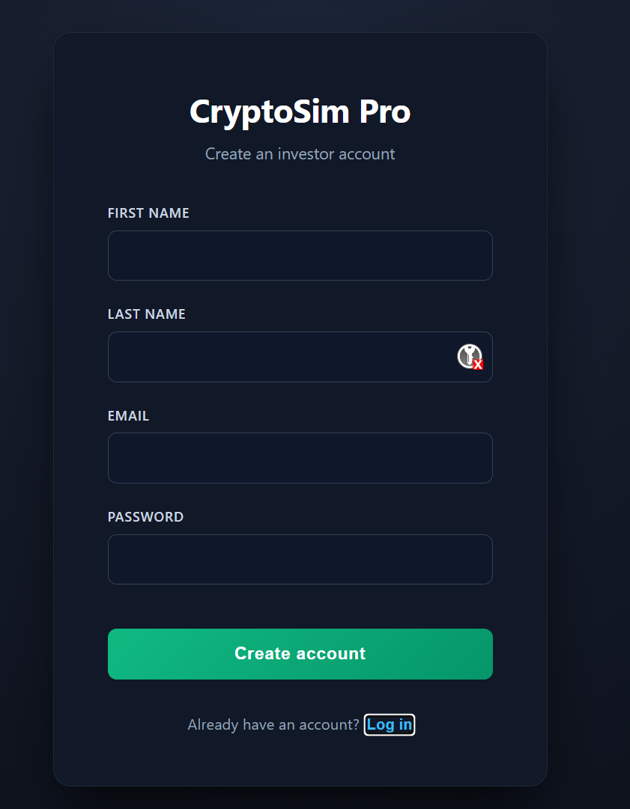

Backend Execution Logs and HTTP Responses

On the server side, structured console logging traces cache hits, external calls and the outcome of each order, while the API returns consistent JSON envelopes. A representative successful execution response is shown below.
POST /api/Trading/execute 200 OK
{
"Success": true,
"Message": "L'ordre de BUY pour 0.5 bitcoin a été exécuté avec succès."
}

[Cache] Market prices served from memory (age < 30s)

Challenges Encountered

Service Lifecycle Conflicts (Resolving the Singleton vs. Scoped dependency issue in the Worker)
The alert worker is a hosted BackgroundService, which the runtime instantiates once, as a singleton, for the whole lifetime of the application. The Entity Framework context (AppDb), by contrast, is registered with a scoped lifetime because it is not thread-safe and is designed to be short-lived. Injecting the scoped AppDb directly into the singleton worker triggers the classic startup error *“cannot consume scoped service AppDb from singleton”*.

The resolution is to inject IServiceScopeFactory into the worker and, on each evaluation cycle, create a fresh scope — using var scope = _scopeFactory.CreateScope();from which a correctly-scoped AppDb is resolved.

This gives the long-lived worker per-iteration database access without leaking lifetimes or sharing a context across threads.
// Resolving a scoped DbContext inside a singleton BackgroundService
using (var scope = _scopeFactory.CreateScope())
{
var db = scope.ServiceProvider.GetRequiredService<AppDb>();
var alerts = await db.PriceAlerts
.Where(a => a.IsActive).ToListAsync();
// ... compare against live prices, deactivate & notify on breach ...
}

High-Frequency Filtering and Performance Optimization
CoinGecko's demo tier imposes a tight call budget (on the order of a few dozen calls per minute). With several users polling the market and every trade requiring a fresh price, naïve per-request calls would exhaust that budget within seconds and cause failures. The solution is the single shared IMemoryCache entry with a 30-second TTL: all users read from the same cached snapshot, collapsing many would-be external calls into at most one per interval.
Within the hot path of a trade, the price list is projected into a dictionary keyed by asset id for O(1) lookups, and the whole portfolio is valued in a single in-memory pass. Together these choices keep price resolution off the network and off the database wherever possible, which is what makes validation feel instantaneous.

WebSocket Network Security

An always-open push channel widens the attack surface, so the alert socket is designed around three principles.
- First, the connection is authenticated with the same JWT used by the REST API rather than left anonymous. - Second, allowed origins are restricted through the existing CORS policy, so only the trusted SPA origin may open a socket.
- Third, every message is scoped to its owner, so a client can only ever receive its own alert notifications and never another user's.

Conclusion

Project Summary and Key Achievements

Within a four-week cycle, the project delivered a working prototype covering the mandatory requirements: - secure Identity-plus-JWT authentication;
- live ingestion of a ten-asset market with shared caching;
- a validated virtual trading engine that applies a realistic fee and enforces cash,
- exposure and short-selling rules;
- portfolio analytics spanning NLV,
- cash, allocation and unrealized P&L;
- a global leaderboard;
- and watchlist and price-alert features.

All of this sits behind a clean N-tier back end that mirrors a real trade lifecycle: Front, Middle and Back Office and a responsive React front end.

The most valuable outcome is not any single feature, but the financial correctness and separation of concerns baked into the design: exact decimal arithmetic, an immutable ledger, atomic settlement, and risk validation kept independent from booking.é

Technical Scalability and Future Enhancements
Several avenues would take the prototype toward production readiness:
- Replace REST polling with streaming exchange WebSocket feeds for genuinely real-time prices.
- Move alert evaluation to a horizontally-scalable worker fed by a message queue, and adopt a distributed cache (Redis) so both caching and alerts survive across multiple instances.
- Add richer order types (limit, stop-loss) and partial-fill semantics.
- Introduce refresh-token rotation with shorter access-token lifetimes, and enable JWT issuer/audience validation for production.
- Paginate the history and market endpoints and add server-side leaderboard aggregation.
- Containerize the stack with Docker, add a CI/CD pipeline, and instrument the system with structured logging, metrics and tracing.
- Complement the Bruno collection with automated integration tests (e.g. xUnit) run on every commit.

